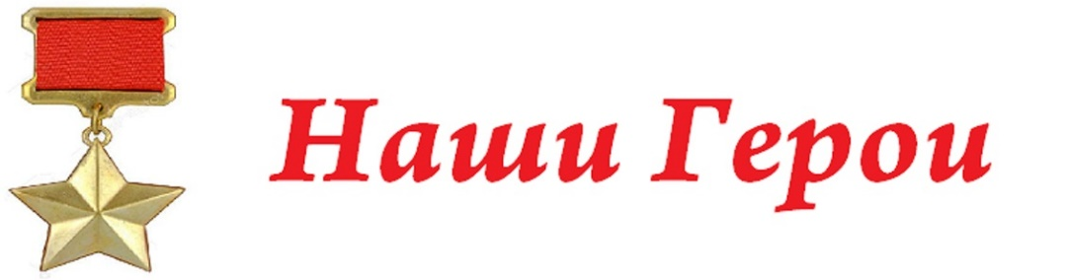
РОСТОВЧАНЕ – ГЕРОИ СОВЕТСКОГО СОЮЗА
и ПОЛНЫЕ КАВАЛЕРЫ ОРДЕНА СЛАВЫ
ВОРОШИЛОВСКИЙ РАЙОН
1. Семён Исаакович Гурвич
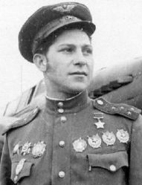
https://ru.wikipedia.org/wiki/%D0%93%D1%83%D1%80%D0%B2%D0%B8%D1%87,_%D0%A1%D0%B5%D0%BC%D1%91%D0%BD_%D0%98%D1%81%D0%B0%D0%B0%D0%BA%D0%BE%D0%B2%D0%B8%D1%87
2. Валентин Павлович Зверев
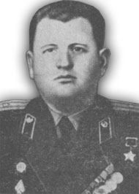
https://ru.wikipedia.org/wiki/%D0%97%D0%B2%D0%B5%D1%80%D0%B5%D0%B2,_%D0%92%D0%B0%D0%BB%D0%B5%D0%BD%D1%82%D0%B8%D0%BD_%D0%9F%D0%B0%D0%B2%D0%BB%D0%BE%D0%B2%D0%B8%D1%87

3. Ольгерд Тихонович Кравцов
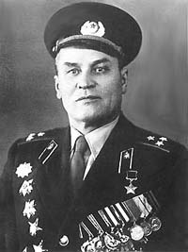
https://ru.wikipedia.org/wiki/%D0%9A%D1%80%D0%B0%D0%B2%D1%86%D0%BE%D0%B2,_%D0%9E%D0%BB%D1%8C%D0%B3%D0%B5%D1%80%D0%B4_%D0%A2%D0%B8%D1%85%D0%BE%D0%BD%D0%BE%D0%B2%D0%B8%D1%87

4. Малый Сергей Дмитриевич
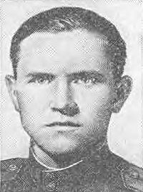
https://ru.wikipedia.org/wiki/%D0%9C%D0%B0%D0%BB%D1%8B%D0%B9,_%D0%A1%D0%B5%D1%80%D0%B3%D0%B5%D0%B9_%D0%94%D0%BC%D0%B8%D1%82%D1%80%D0%B8%D0%B5%D0%B2%D0%B8%D1%87
5. Иван Павлович Нечаев
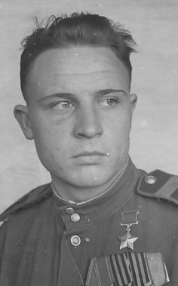
https://ru.wikipedia.org/wiki/%D0%9D%D0%B5%D1%87%D0%B0%D0%B5%D0%B2,_%D0%98%D0%B2%D0%B0%D0%BD_%D0%9F%D0%B0%D0%B2%D0%BB%D0%BE%D0%B2%D0%B8%D1%87
6. Николай Никифорович Мороз
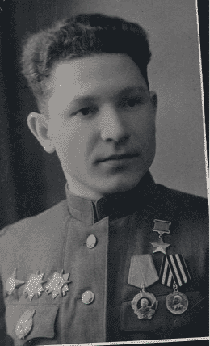
https://ru.wikipedia.org/wiki/%D0%9C%D0%BE%D1%80%D0%BE%D0%B7,_%D0%9D%D0%B8%D0%BA%D0%BE%D0%BB%D0%B0%D0%B9_%D0%9D%D0%B8%D0%BA%D0%B8%D1%84%D0%BE%D1%80%D0%BE%D0%B2%D0%B8%D1%87
7. Михаил Григорьевич Молодиков
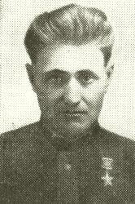
https://ru.wikipedia.org/wiki/%D0%9C%D0%BE%D0%BB%D0%BE%D0%B4%D0%B8%D0%BA%D0%BE%D0%B2,_%D0%9C%D0%B8%D1%85%D0%B0%D0%B8%D0%BB_%D0%93%D1%80%D0%B8%D0%B3%D0%BE%D1%80%D1%8C%D0%B5%D0%B2%D0%B8%D1%87

8. Василий Иванович Московенко

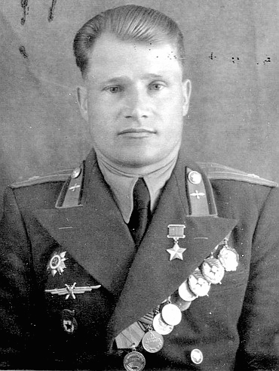
https://ru.wikipedia.org/wiki/%D0%9C%D0%BE%D1%81%D0%BA%D0%BE%D0%B2%D0%B5%D0%BD%D0%BA%D0%BE,_%D0%92%D0%B0%D1%81%D0%B8%D0%BB%D0%B8%D0%B9_%D0%98%D0%B2%D0%B0%D0%BD%D0%BE%D0%B2%D0%B8%D1%87

9. Алексей Иванович Олепир
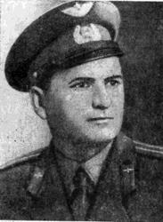
https://ru.wikipedia.org/wiki/%D0%9E%D0%BB%D0%B5%D0%BF%D0%B8%D1%80,_%D0%90%D0%BB%D0%B5%D0%BA%D1%81%D0%B5%D0%B9_%D0%98%D0%B2%D0%B0%D0%BD%D0%BE%D0%B2%D0%B8%D1%87

10. Николай Ермолаевич Самохин
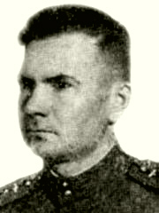
https://ru.wikipedia.org/wiki/%D0%A1%D0%B0%D0%BC%D0%BE%D1%85%D0%B8%D0%BD,_%D0%9D%D0%B8%D0%BA%D0%BE%D0%BB%D0%B0%D0%B9_%D0%95%D1%80%D0%BC%D0%BE%D0%BB%D0%B0%D0%B5%D0%B2%D0%B8%D1%87

11. Николай Николаевич Орищенко
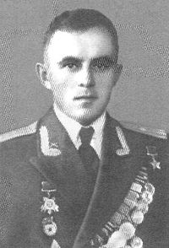
https://ru.wikipedia.org/wiki/%D0%9E%D1%80%D0%B8%D1%89%D0%B5%D0%BD%D0%BA%D0%BE,_%D0%9D%D0%B8%D0%BA%D0%BE%D0%BB%D0%B0%D0%B9_%D0%9D%D0%B8%D0%BA%D0%BE%D0%BB%D0%B0%D0%B5%D0%B2%D0%B8%D1%87

12. Василий Иванович Харитошкин
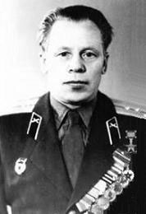
https://ru.wikipedia.org/wiki/%D0%A5%D0%B0%D1%80%D0%B8%D1%82%D0%BE%D1%88%D0%BA%D0%B8%D0%BD,_%D0%92%D0%B0%D1%81%D0%B8%D0%BB%D0%B8%D0%B9_%D0%98%D0%B2%D0%B0%D0%BD%D0%BE%D0%B2%D0%B8%D1%87

13. Шалашов Сергей Михайлович
https://ru.wikipedia.org/wiki/%D0%A8%D0%B0%D0%BB%D0%B0%D1%88%D0%BE%D0%B2,_%D0%A1%D0%B5%D1%80%D0%B3%D0%B5%D0%B9_%D0%9C%D0%B8%D1%85%D0%B0%D0%B9%D0%BB%D0%BE%D0%B2%D0%B8%D1%87

14. Андрей Андреевич Шипулин
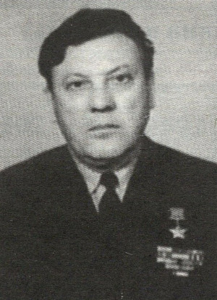
https://ru.wikipedia.org/wiki/%D0%A8%D0%B8%D0%BF%D1%83%D0%BB%D0%B8%D0%BD,_%D0%90%D0%BD%D0%B4%D1%80%D0%B5%D0%B9_%D0%90%D0%BD%D0%B4%D1%80%D0%B5%D0%B5%D0%B2%D0%B8%D1%87

